**Intralocus sexual conflict explored through male-limited selection in *Drosophila melanogaster*: A failure to replicate.**

Harshavardhan Thyagarajan1, Imran Sayyed1, Mindy G. Baroody1, Joshua A. Kowal1, Troy Day1 and Adam K. Chippindale1

**Keywords**

Intralocus sexual conflict, genetic variance, experimental evolution, *Drosophila melanogaster*

**Author institutional affiliations**

1 - Queen’s University, Kingston, Ontario.

**Corresponding author contact details**

Harshavardhan Thyagarajan <17ht24@queensu.ca>

**Author contributions**

HT, TD and AKC developed the overall theme of the study; HT and AKC designed the experiments; HT, IS, MGB, JAK & AKC carried out the experiments; HT analysed the data; HT wrote the first draft of the paper; HT, TD and AKC contributed to the final draft and revisions.

**Conflict of interest statement**

The authors declare no competing interests.

**Acknowledgments**

Several undergraduate students were involved in lab maintenance and data collection during the period of this study. We thank Avery Want, Amanda Wigney, Navageevan Navamenon, Halle McNamara, Ronni Prince, Katelyn Viau, Alex Montenegro-Monreal, and Simmal Grewal for their efforts. We thank Karl Grieshop for his valuable inputs in interpreting these unexpected results. Funding for the work was from NSERC Discovery grants to AKC & TD.

**Data Accessibility Statement:**

**ABSTRACT**

Due to the shared ubiquity of sex-specific selection pressures and positive genetic trait correlations between the sexes*,* intralocus sexual conflict(IaSC) is predicted to be common and relevant to the evolutionary genetics of sexually reproducing populations. Direct tests of the contributions of IaSC to these phenomena are challenging to conduct, and limited. In this study, we utilize a sex-limited selection experiment, designed to subject haplotypes of *Drosophila melanogaster* to selection for male fitness without opposing selection acting on female fitness. In contrast with previous studies employing this technique, we find that male fitness of haplotypes subject to male-limited (ML) selection are not significantly better than their matched controls (MC). Males from ML lines do not outperform controls in mate choice trials, fecundity induction or sperm offense. They show no signatures of driving sex chromosomes (measured in the form of biased sex ratios). Genetic variation for male fitness was reduced by selection, but this was only surveyed in one replicate population pair and included a potential artefact in the protocol. On the other hand, female fitness in ML lines declined relative to controls as predicted by sexually antagonistic variation. These results bring into question the ubiquity of IaSC in *D. melanogaster* populations. However, we also discuss some likely artefacts that may obscure our ability to detect IaSC altogether.

**INTRODUCTION**

Anisogamy of the sexes triggers an adaptive cascade that causes sex-specific selection pressures, resulting in different morphological, life-history, reproductive and ecological strategies. Despite sex specific selection pressures being common, most traits genes show positive genetic correlations between the sexes (Poissant *et al.* 2010). These correlations are expected to act as constraints the evolution of dimorphic responses to selection. This inability to evolve to the fitness optimum in either sex results in a conflict between the sexes, labelled intralocus sexual conflict (IaSC).

The empirical examination of IaSC is a field in relative infancy. After the formalisation of theory in the 1970s (Kidwell *et al.* 1977; Parker 1979, Lande 1980), early experimental evidence for the existence of IaSC was provided by Chippindale *et al.* (2001) in the form of a negative genetic correlation for reproductive fitness between the two sexes. This measure of intersex (or cross-sex) genetic correlation for fitness (r*w,g,m-f*) has since been used to investigate the existence of IaSC, with negative measures of r*w,g,m-f* treated as evidence for IaSC (cf. Connallon & Matthews 2019). These calculations are typically applied to forms of cytogenetic cloning (hemiclonal analysis), half-sib breeding designs, or sex-specific parent-offspring fitness data, and have been used to identify a number of species undergoing IaSC including fruit flies, seed beetles, zebra finches, ground crickets, meal moths, plants, lizards, snakes and red deer (reviewed in Bonduriansky & Chenoweth 2009; Poissant *et al.* 2010; Connallon & Matthews 2019).

Besides measurements of intersex genetic correlations for fitness at the species / population level, a second key focus of this literature has been on specific traits that are potential fulcrums of sexual antagonism. In the absence of sex-specificity of traits, the evolution of adaptations to sex-specific selection pressures is constrained by the shared genome (Lande 1980). While sex-specific adaptation may be accomplished through a number of genomic mechanisms, such as duplications, sex chromosomes, imprinting, or in cis-regulation, even dimorphic traits may harbour unresolved sexual conflict. Through measurements of extant trait values and fitness optima (estimated using selection gradients), dimorphic traits such as body size, wing shape, locomotory activity and development time (amongst others) have been shown to have SA fitness effects (reviewed in Bonduriansky & Chenoweth 2009; Cox & Calsbeek 2009; Singh & Punzalan 2018).

While a growing list of studies catalogue the existence of IaSC and the constraints placed upon trait dimorphism in different species, empirical studies that test theoretical predictions of the consequences of IaSC with respect to the maintenance of genetic variance and the genomic locations of sexually antagonistic loci are limited.

The interest in the distribution of SA loci stems from contradictory theoretical predictions about the SA loci enrichment on the haplodiploid sex chromosome based on differing assumptions about allele dominances (Fry 2010). Assuming identical allelic dominance parameters in males and females, Rice (1984) predicts an enrichment of SA variation on the haplo-diploid X chromosome. In a more general model that considers all possible dominance combinations, Kidwell *et al.* (1977) shows that a less restrictive parameter space allows for similar invasion conditions on autosomes and X chromosomes. Empirical research has so far suggested that the X chromosome does indeed harbour more SA loci than randomly expected (Gibson *et al.* 2002; Pischedda & Chippindale 2006; Long *et al.* 2012; Ruzicka *et al.* 2019, Wong & Holman 2023, but see Lund-Hansen *et al.* 2020, Abbott *et al.* 2020). However, Ruzicka & Connallon (2020) suggest that quantitative genetic methods attempts at identifying SA loci are likely to overestimate the enrichment of SA loci on the X chromosome, due to asymmetric inheritance pattern of X chromosomes. Further, recently unearthed evidence for sex-specific dominance reversals (Grieshop& Arnqvist 2018, Pearse *et al.* 2019, Geeta Arun *et al.* 2021, reviewed in Grieshop *et al.* 2024) contributes weight to Kidwell *et al.*’s assumptions, and predictions of random distribution of SA loci across autosomes and sex chromosomes.

There is little empirical work detailing the maintenance of genetic variance through SA polymorphisms. As a form of balancing selection acting upon the genome constitutively, IaSC is expected to maintain polymorphisms and contribute to genetic variance for traits related to fitness. However, while the conditions for sexually antagonistic selection are nearly ubiquitous, the conditions for their maintenance may or may not be met in nature. Rapid environmental heterogeneity can cause maladaptation, which can align the selection pressures acting on the two sexes, but gradual environmental fluctuations are likely to stabilise antagonistic variation (Connallon & Hall 2016). Furthermore, the “efficacy” of antagonistic selection (i.e., its tendency to dominate over genetic drift) is extremely weak relative to classical models, such as directional selection and over-dominance (Connallon & Clark 2012). Ruzicka *et al.* (2019) show that the SA loci they identify in a lab population display signatures of balancing selection (measured using Tajima’s D and minor allele frequency measurements) and identify similar signatures in distantly related populations of fruit flies*,* suggesting stable balancing selection over long periods of evolutionary time at these loci. More recently, Kaufmann *et al.* (2023) show that artificial sexually antagonistic selection on body size maintains greater genetic variance than sex-limited selection.

At the sequence level, the last few years have produced some remarkable indexing of sexual antagonism on the genome. Some studies have used the *D. melanogaster* hemiclonal analysis system, coupled with statistical techniques to extract an ‘antagonistic fitness axis’ along which they track expression differences (Innocenti & Morrow 2010, although see Rowe et al. 2018), and sequence variants (Ruzicka *et al.* 2019; also see Hill *et al.* 2017). Wong & Holman (2023) approach the same problem using fitness measures and gene expression data for both sexes from the *Drosophila* Genetic Reference Panel. In other species, the absence of such panels and cytogenetic cloning techniques has produced alternative approaches to identifying SA loci. Recently, Dagilis *et al.* (2022) describe a technique to date recombination suppression between sex chromosomes and look for the accumulation of SA polymorphisms in the newly formed pseudo-autosomal region.

A common tactic has been to look at modes of resolution of IaSC to work backwards onto loci of antagonism. Sex linkage and sex-biased gene expression ranging from mildly biased expression to sex-limited expression can provide a direct form of intra-locus sexual conflict resolution, by creating the genetic architecture for phenotypic dimorphism (Day & Bonduriansky 2004; Otto *et al.* 2011; Jordan & Charlesworth 2012; Kirkpatrick & Guerrero 2014; Mank 2017). As a consequence, loci that display such patterns of altered expression are of especial interest as potential sites of ongoing sexual conflict, and have been shown to exhibit signatures of balancing selection (Qiu *et al.* 2013; Cheng & Kirkpatrick 2016; Guirao-Rico *et al.* 2017; Wright *et al.* 2018; Sayadi *et al.* 2019). Wright *et al.* 2018 and Sayadi *et al.* 2019 utilise indicators of balancing selection in conjunction with sex-specific expression data to predict loci under IaSC in guppies and find especially interesting patterns. They show that male-biased (in expression) genes and female biased genes undergo different levels of balancing selection on average, with female biased genes undergoing much higher levels of balancing selection, suggesting that expression changes in loci that are found to be male-biased are generally more successful at resolving IaSC.

In this study, we look to a sex-limited selection protocol (developed by Rice (1996) and pioneered as a tool to study IaSC by Prasad *et al.* (2007)) to address these questions. Using the lack of molecular recombination in *D. melanogaster* males and an independent population of “clone-generator” (CG) females carrying compound-X chromosomes (XXY karyotype) and autosomal translocations, we are able to reliably passage haplotypes containing an X chromosome and all autosomes barring *D. melanogaster*’s dot (4th) chromosome hemiclonally from father to son. Removed from the influence of selection acting upon the female function, we predict that this population of haplotypes will experience a knock-down of IaSC, increasing the frequency of male benefit alleles at SA loci at the cost female benefit alleles. This should result in (1) a phenotype of increased male fitness at the cost of female fitness, (2) masculinization of partially dimorphic traits in both males and females (as in Prasad *et al.* 2007, Abbott *et al.* 2013), (3) a reduction of genetic variance for fitness in males, (4) sequence level divergence between selected and control populations with changes in signatures of balancing selection and (5) changes in patterns of sex biased gene expression.

This male-limited (ML) system holds advantages over other contemporary systems used in the literature. While clonal and breeding designs allow us to study the standing genetic variance for fitness in a population, they only provide us with a meaningful study of intralocus sexual conflict through the usage of correlational analysis using many sampled lines. To probe the system past fitness and identify SA polymorphisms on the genome, there is a need for statistical manipulations, such as the extraction of an antagonism index (Innocenti & Morrow 2010; Hill *et al.* 2017; Ruzicka *et al.* 2019). Further, it is not amenable to examination of other phenotypical trait variances and corresponding analysis. In contrast, the ML selection regime (1) provides a direct experimental manipulation rather than a correlational analysis, (2) allows for statistical simplicity and strength at smaller sample sizes through the amalgamation of male-benefit alleles across many loci in the same individuals, increasing signal-noise ratio and (3) allows us to probe adaptive responses in the phenotype when released from positive trait intersex genetic correlations.

That said, the ML system also has caveats that need to be explicitly stated, stemming from the genetic constructs used in CG females, and the use of CG females themselves. Firstly, the use of females in “arrest” (Rice 1996) (females are sourced from a different population and cannot co-adapt with the males they are exposed to) could result in adaptations specific to these females. Within the genome, the usage of the compound-X (XXY) females to reverse the parent of origin of sex chromosomes may carry selection costs (Abbott *et al.* 2013). (1) Cyto-nuclear interactions between CG female cytoplasm and male nuclear DNA – Given that the XXY females cannot be backcrossed to standardize their cytoplasm using the control population, there remains a possibility for interactions between the cytoplasm of the CG females and the nuclear DNA of the focal males, in the form of mito-nuclear interactions. (2) Maternally inherited Y chromosomes may have undergone feminization or mutation accumulation effects of being expressed in female organisms 50% of the time, which may in turn play a role in the selective environment in which the ML flies are reared. Likewise, the translocated autosomes inherited from these females could produce fitness effects that induce counter adaptations over the course of the selection experiment. Lastly, given that selection acts upon exclusively haploid genomes, there is scope for adaptation to take place through dominance effects, or dosage compensation-like effects. Nevertheless, previous studies have found the system to be a valuable resource despite these artefacts.

Besides the interest in critical open questions, this selection experiment provides a valuable novelty to IaSC studies conducted using *D. melanogaster.* An unfortunate consequence of a tight knit research community is the restriction of studies concerned with IaSC to a limited number of stock populations. Specifically, the LHM’s (LH-moderate density) adapted from Larry Harshman’s LH stock dominate this field (Rice 1996, Rice 1998, Chippindale *et al.* 2001, Gibson *et al.* 2002, Byrne & Rice 2005, Lew & Rice 2005, Lew *et al.* 2005, Linder & Rice 2005, Pischedda & Chippindale 2006; Prasad *et al.* 2007, Long *et al.* 2007, Bedhomme *et al.* 2008, Rode & Morrow 2009, Innocenti & Morrow 2010, Abbott *et al.* 2013, Collet *et al.* 2017, Hill *et al.* 2017, Ruzicka *et al.* 2019, Abbott *et al.* 2020, Lund-Hansen *et al.* 2020, Manat *et al.* 2021, Lund-Hansen *et al.* 2022). Interestingly, Collet *et al.* demonstratethat even recently separated populations (~ 200 generations) of LHM display differences in sexual antagonism. While results from Ruzicka *et al.* (2019) suggests some generality in these findings, it is useful to affirm this notion by conducting experimental work on an alternative baseline populations. Here, we conduct a selection experiment on control-old(CO) (derived from the *Ives* (IV)) populations that have been used as a long-term evolution experiment to study life history traits, correlated adaptations, and speciation (Rose *et al.* 1992; Chippindale *et al.* 1997; Chippindale *et al.* 2004; Xiao *et al.* 2019; Robinson *et al.* 2023).

We report on the competitive reproductive fitness (CRF) of males and females from selected and control lines. Using an improved breeding design, we strip test individuals of all artefacts deriving from the selection experiment. To study contributions to CRF, we further examine test males for mating success, fecundity induction, sex ratio drive and sperm offense. Lastly, we use a hemiclonal analysis to study genetic variance for reproductive fitness in males and females from selected and control populations, and use this design to report on the intersex genetic correlation for fitness in selected and control populations.

As a proof of principle of ML selection, we predict improved male fitness and reduced female fitness for selected haplotypes. Previous work suggests that this improved male fitness should be a consequence of more attractive males that are consistently mated (even with reduced courtship efforts, Bedhomme *et al.* 2008). Due to the reduced genetic variance for the already male limited sperm traits (Friberg *et al.* 2005, Bjork *et al.* 2007, Jiang *et al.* 2011), we anticipate that the improvement of male fitness will not evolve through improved fecundity induction or sperm competitive ability (although see Rice 1996, Rice 1998). Previous work reports no precedent of driving sex chromosomes, and the likelihood of such a mutation is low, but the selection experiment should strongly select for a driving ML-X chromosome by design should it arise. Lastly, we expect ML selection to erode balanced polymorphisms at SA loci through directional selection for male benefit variation, resulting in reduced genetic variance for male fitness.

**METHODS**

***ML Selection***

*Source populations*

Our experiments employed selected and control populations (COs) originating from the IVs. These in turn were initiated in 1975 from a sample of wild-caught flies in South Amherst (MA, USA), and maintained under standardized culture conditions for ~500 generations since 1980 (Rose 1984). Three replicate CO populations (CO1, CO3, CO5) (traditionally kept separately on discrete 4-week generation cycles since 1989,) were arbitrarily chosen from the five replicate CO’s and were maintained in a 2-week cycle (day 1-11 in vials, followed by days 12-14 in ~ 3 litre population cages with food in a petri-dish) for 24 generations. After 24 generations, a male-limited (ML) line and matched-control (MC) line was derived from each of the three replicate populations. These were correspondingly labelled ML1-MC1, ML3-MC3, and ML5-MC5. All populations were maintained under standard laboratory conditions: moderate density (larval density of 80 - 100 larvae / vial), 25ºC, 12:12 light:dark cycle on banana/agar/killed-yeast medium, and with a census population size of ~1,000 haploid genomes per generation.

*Selection treatment*

ML selection lines were established nearly identically to the protocol described in Prasad *et al.* (2007) (fig. S1a). Briefly, 1,000 males from the replicate base population were mated to “clone-generator” (CG) females that carried a compound X(C(1)DX*, y, f* ), a Y chromosome and a homozygous-viable translocation of the two major autosomes (T(2 : 3)*rdgc st in ri pp*). Using the genetic markers for eye colour, the absence of molecular recombination in males, and the aneuploid mortality experienced by animals inheriting uneven combinations of translocated autosomes, we select sons carrying a haploid genome from their sire, and repeatedly cross these sons to CG females to passage these haploid genomes under conditions of ML selection. 1000 such males were collected under light CO2 anaesthesia each generation on day 10-11 post oviposition (PO) and were combined on day 12 with virgin CG females of matched age in 3 cages (333-334 males and females in each cage). Eggs were collected from these cages on day 14 at a density of 320-400 eggs per vial, to achieve a larval density of 80-100 per vial after accounting for aneuploid viability costs. To match these conditions, 500 males (1000 haploid genomes) from each MC line collected under light CO2 anaesthesia each generation on day 10-11 PO and combined on day 12 with virgin MC females in 2 cages (250 pairs per cage). Eggs were collected from these lines at a density of 80-100 per vial, with 20 vials dedicated to females and virgin collection and 20 to male collections.

*Recombination Box*

In the absence of molecular recombination in males, and the artificial prevention of independent assortment of chromosomes, the ML selection regime is not only sex-limited, but also asexual in propagation, exposing it to reduced rates of adaptation and genetic hitchhiking. We follow the system described in Prasad *et al.* (2007) and express some randomly selected pairs of ML haploid genomes in female flies each generation to facilitate recombination and limit hitchhiking and background selection. These recombinant (RC2) females carry completely ML derived genomic content and are used to dam male offspring with recombined DNA that are re-introduced into the ML population the next generation.

To facilitate recombination in each generation, we collected 50 ML males from each replicate population and crossed them to virgin CG females carrying an additional dominant eye colour marker (*bwD*). Sons derived from this first recombination cross (RC1) carrying haploid genomes of interest are brown eyed due to their single copy of *bwD*. 50 sons (RC1 males) were crossed to control females, and daughters carrying two ML haploid genomes (identified through absence of *bwD*) from this second recombination cross (RC2) are collected as virgins to establish a line of females that receive ML genetic content through backcrossing with RC1 males. Within 4 generations of backcrossing these females are ~95% ML in genome content. In each generation after the first generation of the experiment, 70-80 virgin RC2 females were collected and crossed to 50 RC1 males. 50 male offspring from this cross (RC2 males) carrying haploid genomes of interest (rather than translocated autosomes - identified through absence of *bwD*) from RC1 fathers and recombined gametes from RC2 mothers are re-introduced into the selected population from which the RC was derived (fig. S1b).

*Experimental animals*

We expressed the target (ML and MC) haploid genomes in male and female flies, with an attempt to produce test animals that avoid all sources of artefact from the ML selection regime, including the reversed inheritance of sex chromosomes, the foreign cytoplasm, the maternally inherited Y chromosome, and the translocated autosomes. To do this, we used males and females produced from the second recombination cross in the ML treatment. Through many generations of backcrossing of ML genetic content into a control derived line, we were able to produce RC2 flies carrying ML genetic content without the associated artefacts. To create the actual test animals, we used a crossing design between RC2 and MC flies.

From a full factorial crossing design, 4 types of male offspring and 3 types of female offspring can be obtained (fig S2a). From crosses of MC males and females, we derive our control treatment of test animals (male and female), also labelled MC. From RC2 males and females, we can derive flies carrying completely ML type genomes, labelled MLDD (ML double dose). Both directions of the hybrid cross produce identical females, carrying an ML haploid genome. These, like males carrying a single complete haploid genome from the ML treatment are labelled MLSD (ML single dose). While crosses with MC sires and RC2 dams produce MLSD males, crosses between RC2 sires and MC dams produce males carrying an X chromosome from MC populations and a single dose of ML autosomes. These males are labelled MLSD(a). Crossing designs used were not fully factorial in all the experiments reported below, but the labelling scheme indicates the crosses carried out as described here. The different test animals studied were denoted using the variable ‘Treatment’ in analysis.

While fitness assays were conducted using test animals as described above, a slightly different design was used to produce test animals for mate choice, sperm competition, body size and development time assays (fig S2b). Here, test animals were produced using a cross analogous to the second recombination cross used for generating RC2 males to create both ML and MC test flies. First, ML and MC male haplotypes are captured using CG (*bwD*) females. Sons from these crosses carrying the haplotypes are crossed to virgin MC or RC2 females to produce test flies. Here too, as before, the treatments are labelled as per the system above (MC, MLDD, MLSD, MLSD(a)). While mostly identical to the design used for fitness assays, the male test animals from this design carry Y chromosomes from clone generator lines that may have been exposed to feminization or mutation accumulation effects. Due to this oversight, it is possible that there are effects in the phenotypes displayed by the test animals in response to the Y chromosome.

To study genetic variance for fitness in these populations, we created hemiclonal lines (as described in Chippindale *et al.* 2001) using single haploid ML-1 and MC-1 genomes sampled through crosses with CG females. Each individual haplotype was amplified entirely in sons using crosses with CG (*bwD*) females; and had its X chromosome passaged to a daughter using crosses with a female carrying MC derived autosomes and balancer X chromosomes (fig S3). These sons and daughters respectively were then crossed to one another to produce test animals carrying ML and MC haplotypes, along with control derived autosomes. Females derived were homozygous for the X chromosome, and males carried the Y chromosome from the CG (*bwD*), much like the test animals from the mate choice and sperm competition assays.

Across all assays, test animals were maintained at a larval density of 80-100 animals per vial. Virgin flies were collected 6-8 hrs from eclosion using light anaesthesia between days 8-10 PO. Non virgin test animals were collected on days 10-11 PO.

Fitness, mate choice and sperm competition assays required the use of phenotypically marked competitors. These lines allow us to identify successful mates and measure competitive siring/damming success by distinguishing the progeny phenotype. To this end, we backcross a recessive eye colour markers into control derived lines to create these competitor populations. Two such populations are created, combining flies across the different replicate populations of the MCs. In the first, we introduce the pink-peach (*p*p) eye colour marker, and in the other we introduce the brown (*bw1*) eye colour marker. Collectively, we refer to these lines as recessive competitors – “Cr”.

***Assays***

*Competitive Reproductive Fitness (CRF) assays*

CRF for was assayed for both males and females. Following the crossing design, test females were collected as virgins, and test males were collected on day 10-11. On day 12, 30 test animals were combined with 30 Cr individuals of the same sex, and 50 Cr of the opposite sex (both carrying the recessive eye colour marker). These animals were held together in mini cages with ad libitum yeast between days 12-14 PO, to mimic the reproductive conditions of the selection treatment. For each treatment (within each replicate pair of lines), we assessed 6 such competition arenas (labelled contests in analysis), and collected 6 vials of eggs to measure CRF.

Male CRF was assayed thrice, in generations 50, 64 & 70 of the selection experiment. In generations 50 and 64, only MLSD and MC animals were tested. All four were tested in generation 70. For the experiment conducted in the 70th generation, males were collected as virgins. Female CRF was assayed twice, in generations 48 & 50 of the selection experiment. On both occasions, we only tested MLSD and MC animals.

*Hemiclonal analysis of fitness*

Conducted in generation 78, CRF assays for hemiclonal analysis were designed very similarly to the CRF assays described above for males. The competition size was reduced in response to the increase in number of lines being studied. Here, we combined 4 test males with 4 Cr males and 6 Cr females. For female fitness, 4 virgin test animals were combined with 3 Cr males. Rather than competitive reproductive fitness, female productivity was assayed as a proxy for fitness. In both sexes, up to 5 such contests were set up for each line, depending on the availability of usable test animals. Complete hemiclonal data for both sexes was collected from 76 lines out of an initially sampled 80.

*Mating success assays*

We assayed female mate choice (or male mating success) in generation 66, using progeny eye colour. Progeny were also sexed and enumerated to test for fecundity induction and sex ratio drive effects. Following the crossing design, test males were collected on day 10-11. On day 12, single test males were combined with a Cr male, and a Cr virgin female. When one of the two possible pairs begin copulation, the excess male was aspirated out by gently removing the foam plug without disturbing the pair in copula. After the mating ended and animals separated, the remaining male was also removed, and the female was left undisturbed to oviposit for 48 hours under *ad-libitum* yeast conditions. The time of introduction (observation start time), amplexus formation (mating start time) and separation (mating end time) were noted, which provides us measures of mating latency and mating duration. The offspring sired in each vial were sexed and enumerated. The eye colour of the offspring in each vial was noted to identify the sire that successfully mated. For each treatment (within each replicate pair of lines), we assessed 50 such competition vials.

*Sperm offense assays*

Sperm offense (or P2) was assayed (in generation 74) by serially mating Cr females first to Cr males and subsequently to target males. Following the crossing design, test males are collected on day 10-11. On day 12, 12 virgin Cr females with *ad-libitum* yeast nutrition are combined in vials with males from the same population. Matings were observed carefully until the point that synchronous observations were possible (if some matings end before other matings begin, it is not possible to identify if a single female was mated twice, or if all the females were mated singly. Although unlikely, as recently mated females tend to be unreceptive, it is possible that this system allows for some females to be multiply mated. This is however consistent across all the treatments). In all vials, at least all but 2 females were directly observed to have been mated. Using a treatment where no second male was provided, we found that this system resulted in 97% fertile females. An hour after synchronous matings ended, the flies were gently anaesthetized with CO2, and males were discarded. On day 13, 10 test males were combined with females. Second matings were observed carefully to ensure that no single female was multiply mated at this stage. To achieve this, we observe all the vials to note when matings began in these vials and continue observing the vials for a period of ~3 hours after this point to note the number of matings seen, at the end of which the males were discarded to ensure that the first mated female does not return to a receptive state. We then randomly selected 10 females and transferred them to individual test tubes with *ad-libitum* yeast to oviposit for 24 hours, after which they were discarded. Due to the arbitrary cut-off in the second mating period, dictated by the first pair to copulate in each vial, we do not compare the number of matings achieved by target males in each treatment, instead assessing the proportion of offspring sired where a second mating has successfully taken place. Offspring from each tube were phenotyped by eye colour and enumerated. For each treatment (within each replicate pair of lines), we assessed 30 such competition vials.

*Statistical Analysis*

Statistical analysis was conducted in R version 4.2.3 -- "Shortstop Beagle" (R Core Team 2023). Data was visually assessed for residual normality and using Bartlett’s test for residual heterogeneity. Where generalised linear models were used, residual dispersion was tested using the DHARMa package (Hartig 2022).

Linear mixed models were employed to analyse CRF. Treatment and replicate population were used as fixed factors in the analysis to explain the proportion of offspring sired/dammed by the target individuals. To avoid pseudo-replication, contest was included as a random factor. Where significant differences were identified, we employed planned contrasts between the treatments in a single replicate population pair with a corrected alpha value.

In the hemiclonal analysis of fitness, we analysed genetic variance for fitness in each selection regime, for each sex, using a random effects model that explained the proportion of offspring sired / dammed by the target individuals, using the hemiclonal line as a random factor. The proportion of variance explained by the random factor line was then compared between selection treatments using an F test. Fitness data from the hemiclonal analysis was also analysed using a mixed model, where selection was used as a fixed factor. Here, we did not include replicate as in the case of CRF, as the study was conducted only on replicate population pair 1. Here too, line was included as a random factor. Additionally, mean estimates of male fitness and female fitness for each line from each selection regime were analysed using a Pearson correlation test to test if the ML population displayed a different intersex genetic correlation for fitness from the control. The correlation coefficients were compared against one another using a Fisher’s Z transformation.

To study the mating success of target males in female mate choice trials, we used a generalized linear model with a binomial distribution. The proportion of mating successes for target animals was explained using selection and replicate as fixed factors. Likewise, log(mating latency), mating duration, fecundity induction (offspring count) and sex drive (offspring sex ratio) were analysed using a Gaussian distribution for tubes, with selection and replicate as fixed factors.

For sperm offense, the proportion of offspring sired by the second male was analysed in two steps, as if in a Hurdle model. First, to create a data transformation that enabled the analysis, we subtracted the proportion of offspring sire from 1. This inverted measure was then separated in two parts – values of zero (where all the offspring are sired by the target male) and non-zero values. The number of zeroes attributable to each treatment was analysed as a generalized linear model with a binomial distribution, using treatment and replicate as fixed factors.

**RESULTS**

***Competitive reproductive fitness (CRF)***

*Male fitness*

In generations 50 and 64, we found no effect of treatment, replicate or their interaction on male CRF (tableA1a). In generation 50, MLSD displayed a CRF of 0.3399 +/- 0.0125 (mean +/- 1.96*se) compared to 0.3215 +/- 0.0149 for MC (fig 1a). In generation 64, these figures were 0.3406 +/- 0.0178 and 0.3222 +/- 0.0171 respectively (fig 1b).

In generation 70, we found a significant effect of treatment on reproductive fitness (p < 0.001), and no effect of replicate or their interaction term (although the interaction term approached the α = 0.05 threshold) (table S1b). Excluding replicate (and the corresponding interaction term), we conduct pairwise contrasts between all 4 treatments to find that the only significantly different pairs were MLSD-MLDD (Tukey adjusted p = 0.006) and MC-MLDD (Tukey adjusted p = 0.01). CRF for each treatment (fig 2.2) was as follows: MC (0.4508+/-0.0183), MLSD (0.4730+/-0.0172), MLSD(a) (0.4172+/-0.0176), MLDD (0.3719+/-0.0158).

*Female fitness*

n generation 48 we found a significant effect of selection treatment (p < 0.0001) on CRF, and no effect of replicate or their interaction term on CRF (table A3a). MLSD females displayed a CRF of 0.5269+/-0.0132, and MC females 0.6280+/-0.0120 (fig 1c).

In generation 50, we found a significant effect of selection treatment (p < 0.0001), replicate (p < 0.0001) and the interaction term (p < 0.001) on CRF (table A3a). Here too, MLSD females displayed reduced CRF compared to MC animals. Contrasts between treatments within each replicate revealed that the difference between MLSD and MC females of replicate 5 was not significant (p = 0.074) at the adjusted α = 0.017 threshold for 3 comparisons. Here too, the MLSD mean was found to be lower than that of MC. Overall, ML females displayed a CRF of 0.5072+/-0.0189, and MC females 0.6308+/-0.0120 (fig 1d).

***Hemiclonal analysis of fitness***

*Male fitness*

We quantified genetic variance for fitness for both ML (0.0509) and MC (0.1771) males as the proportion of variance attributed to ‘line’ in a random effects model. Using an F(37, 37) test, we found that these variances were significantly different from one another (p = 0.0001) (table A2a). Male fitness analysed using selection as a fixed factor and line as a random factor revealed an effect of selection (p < 0.0001) (table A2c). This model did violate the Bartlett’s test for homogeneity of variances, but as shown above, that is likely a feature rather than a bug here. Overall, ML males displayed a CRF of 0.553 +/- 0.0255, compared to MC males 0.455 +/- 0.0385 (fig 3).

*Female productivity*

Likewise, we quantified genetic variance for productivity in ML (0.467) and MC (0.424) females. These were not significantly different from one another in a F(37,37) test (p = 0.39) (table S2b). Female productivity analysed using selection as a fixed factor and line as a random factor revealed no effect of selection (p = 0.29) (table S2c). ML dam productivity was 17.69 +/- 2.049 and for MCs it was 16.09 +/- 1.915.

*Intersex genetic correlation for fitness*

Intersex genetic correlations for fitness for both the ML (ρ = 0.0247) and MC (ρ = 0.11) population were not significantly different from 0 (table S2d). Likewise, they were not significantly different from one another (p = 0.34) (table S2e).

***Mate choice assays***

*Mate choice*

We find no effect of selection, replicate or their interaction upon the male chosen for mating, mating latency or mating duration (tables S4a, b, c). Across all replicates however, we note a consistent direction of difference in mate choice success. ML males were more successful, with greater differences in replicates 1 (61.7% success for ML vs 50.0% MC) and 3 (56.5% vs 46.5%), but also in 5 (44.7% vs 40.0%) (fig 5a). It is possible that there exists an effect the study was not sufficiently powered to capture. MLs on average showed a mating latency of 13.96 +/- 4.14 mins and a mating duration of 18.43 +/- 1.00 mins. For the MCs, these figures were 14.93 +/- 4.33 mins and 17.95 +/- 1.48 mins respectively (fig 6a, b).

The model analysing mating duration deviated from homogeneity of variances as tested by Bartlett’s test, suggesting a potentially flawed analysis. However, from data visualization it appears that there are no real differences in this dataset, as suggested by the model.

*Fecundity initiation, sex ratio drivers*

We find no effect of selection, replicate or their interaction on fecundity induction, or sex ratio drivers (tables S4d, e). Sex ratio for all the populations hovered around the expected 0.5 mark. ML male offspring were at 0.507 +/- 0.017 and for MCs it was 0.503 +/- 0.028 (fig 6c). ML males induced a fecundity of 51.09 +/- 2.94 offspring in partners, while MC males achieved 50.94 +/- 3.21 (fig 6d).

***Sperm offense***

We find no effect of selection treatment, replicate or their interaction on either of the sequential steps of analysis on sperm competition (tables 5a, b). Proportion of offspring sired by each treatment as a second male was as follows: MC (0.8985+/-0.0271), MLDD (0.8474+/-0.0353), MLSD(a) (0.8855+/-0.0299), and MLSD (0.9034+/-0.254) (fig 5b).

**DISCUSSION**

Sex limitedevolution has been a powerful tool in the study of IaSC. Our study fails to replicate a key proof of principle prediction of this system, the generic improvement of male fitness in haplotypes under male limited selection tested in ancestral conditions. We find no differences in male reproductive fitness or components thereof – namely mating success, fecundity induction and sperm offense. By contrast, we find that female fitness of these haplotypes declines relative to controls as predicted by sexually antagonistic variation. Through a hemiclonal analysis of genetic variance, we demonstrate a significant reduction in heritable variation for male fitness in one selected population relative to its paired control, but in the presence of a potential artefact. We found no change in heritable variation for female fitness, or in the intersex genetic correlation for fitness between selection treatments.

Across three assays of male reproductive fitness, with three replicate pairs each, we found no differences between male limited animals and their matched controls, except for ML males carrying a double dose of ML autosomes being worse than ML males with a single dose. The absence of response to ML selection might be explained by four possibilities. (1) First, if there was no SA genetic variance for fitness in the source populations utilized due to fixation of alleles in loci critical to fitness, selection would not be able to act upon these populations until novel male benefit mutations occur in the population. The base populations used to derive the selection experiment are long domesticated animals, creating the possibility for such fixation events. (2) Alternatively, intralocus sexual conflict is not as pervasive as previously believed in *Drosophila melanogaster* and needs to be studied across more base populations. (3) Third, it is possible (although unlikely) that selected haplotypes are recessive when paired with control haplotypes in males. Specifically, this would require no evolved changes in the selected Xs (haploid as it is in males), combined with recessivity in selected autosomes. (4) Lastly, the adaptive response in these populations could be restricted to the specific selection conditions imposed by the breeding design used. For instance, haplotypes may evolve to be locally adapted to the females used, or in concert with the genetic background they are expressed in. This could also be understood as selection to counter fitness costs imposed by selection artefacts.

We explore these ideas in detail in sibling manuscripts (Thyagarajan *et al.a* (in prep), Thyagarajan *et al.b* (in prep)). Briefly, we find that the selection lines do adapt locally in response to multiple selection artefacts. We find evidence that these populations still have abundant genetic variance to display adaptive responses, and strong evidence against the recessive haplotype hypothesis. Given that we find artefactual adaptation, we are unable to definitively assess the presence/absence of IaSC using this selection experiment.

If the evolved response is dominated by compensatory adaptation to artefacts, the lack of male fitness improvement under the test conditions sans artefact can come about through 2 routes - through local adaptation to selection conditions that (1) does or (2) does not impose a cost upon fitness under ancestral conditions. While scenario (2) is directly in agreement with the results described herein, scenario (1) requires us to explain why there is no difference in male fitness in our assays. To explain this, we note that it remains possible (although not parsimonious) that the selection experiment simultaneously results in a generic improvement in male fitness as predicted, combined with a reduction in fitness in testing conditions, relative to locally adapted controls.

In keeping with predictions, ML female fitness was found to be lower than MC female fitness. In previous studies, the decline in female fitness of ML selected haplotypes, combined with the masculinization of phenotype was treated as clinching evidence of IaSC. In the context of the results in this study however, it must be noted that this could simply be due to a relaxation of selection acting upon female-limited loci of the genome. Alternatively, such a consistent reduction in female fitness might also come about from sexually antagonistic costs. Here, SA fitness costs experienced by selected haplotypes in females may be consistent across local and ancestral conditions, while male benefit variation that is specific to the local conditions of selection.

Besides these curious results, we were also initially surprised to find low male CRF across MLs and MCs (~1/3rd) when the number of target males and competitors in competition arenas were the same (similar female assays showed CRF values greater than 50%). This led us to wonder if there was an effect of female preference for conspecific males in the competitor populations used. We also noted that competitor males were being collected as virgins along with their females for convenience, unlike the target males. Using virgin target males in the third assay in generation 70, we found higher CRF values around 0.45-0.47, suggesting that male status did play a role. However, it is possible that a conspecific preference also exists, given that the values still did not hit 50%.

For the remainder of results described, the target males of all treatments include a CG derived Y chromosome. We found a suggestive (but not statistically significant) trend of ML males gaining more success in mating trials, but no differences in latency to mating, duration of mating, fecundity induced, offspring sex ratio, or sperm offense.

We cautiously interpret these results to be in agreement with our primary finding of no male fitness differences between selected and control animals. While the analysis of mating trials shows no effect of selection on mating success, we note that this could be due to the limited sample size in the context of a binary variable.

Previous experiments are equivocal about the evolution of sperm competition traits in response to male-limited selection. Rice (1996), (1998) found selected animals to have evolved in a greater sperm offense capability against both CG and non-CG females, and improved sperm defense, but only with CG females. Working with the same base population, Jiang *et al.* (2011) found no difference between selected and control males in terms of sperm offense or defense, against either female type. Here, we find no improvement in sperm offense in selected animals, against non-CG females. We interpret this as a generic lack of improvement in sperm offense, independent of artefacts.

In the hemiclonal analysis, we identified that genetic variance for male fitness was lower for ML1 compared to MC1 as predicted. Genetic variance for female productivity was not different between ML1 and MC1. However, we also found that male ML1 fitness was greater than male MC1 fitness, and female ML1 productivity was not different to MC1 productivity, in seeming contradiction with the CRF results. First, we note that for logistical ease we chose to assay female productivity here, rather than CRF. Unlike CRF, productivity as assayed does not depend on sexual selection or inter-locus sexual conflict (IeSC), which might explain the absence of difference identified. For male fitness, we interpret this difference in male CRF between the two populations as being a response to CG derived Y chromosome. Therefore, we do not feel confident in interpreting this reduction in genetic variance for male fitness in MLs as a response to the removal of balancing selection. It could simply be inflated genetic variance for fitness in the MCs that are exposed to a novel selection artefact resulting in more variable fitness outcomes. Another point of interest was the difference in genetic variance estimates for CRF in males and productivity in females. The heritable variation for female productivity being much higher could be because of stronger sexual selection on males. However, this may also be a consequence of productivity being assayed in females rather than CRF.

Overall, we find that more than 80 generations of male limited selection do not result in a phenotype of increased male fitness when these genomes are expressed in the absence of artefacts associated with selection. In previous iterations of male limited selection experiments, such fitness effects have been identified consistently, using a different source population (LHM), and in the presence of selection artefacts as in Rice (1996) (fitness tested under selection conditions), Rice (1998) (CG derived Y chromosomes, double dose haplotypes), Prasad *et al.* (2007) (translocated autosomes, CG derived Y chromosomes and CG females) and Abbott *et al.* (2013) (CG derived cytotypes, Y chromosomes and reversed sex chromosome inheritance). Our results suggest the need to generalise these findings across more baseline populations, with improved controls to account for potential artefacts.

**REFERENCES**

Abbott, J.K., Innocenti, P., Chippindale, A.K. & Morrow, E.H. (2013). Epigenetics and Sex-Specific Fitness: An Experimental Test Using Male-Limited Evolution in Drosophila melanogaster. *PLOS ONE*, 8, e70493.

Abbott, J.K., Chippindale, A.K., Morrow, E.H. (2020). The microevolutionary response to male-limited X-chromosome evolution in *Drosophila melanogaster* reflects macroevolutionary patterns. *Journal of Evolutionary Biology,* 33, 738–750.

Bedhomme, S., Prasad, N.G., Jiang, P.P. & Chippindale, A.K. (2008). Reproductive Behaviour Evolves Rapidly When Intralocus Sexual Conflict Is Removed. *PLOS ONE*, 3, e2187.

Berg, E.C. & Maklakov, A.A. (2012). Sexes suffer from suboptimal lifespan because of genetic conflict in a seed beetle. *Proceedings of the Royal Society B: Biological Sciences*, 279, 4296-4302.

Bjork, A., Starmer, W.T., Higginson, D.M., Rhodes, C.J., Pitnick, S. (2007). Complex interactions with females and rival males limit the evolution of sperm offence and defence. *Proceedings of the Royal Society B: Biological Sciences*, 274, 1779-88.

Bonduriansky, R. & Chenoweth, S.F. (2009). Intralocus sexual conflict. *Trends in Ecology & Evolution*, 24, 280-288.

Byrne, P. G. , Rice, W. R. (2005). Remating in *Drosophila melanogaster*: an examination of the trading‐up and intrinsic male‐quality hypotheses, *Journal of Evolutionary Biology*, 18(5), 1324–1331.

Cheng, C. & Kirkpatrick, M. (2016). Sex-Specific Selection and Sex-Biased Gene Expression in Humans and Flies. *PLOS Genetics*, 12, e1006170.

Chippindale, A.K., A.M. Leroi, H. Saing, D.J. Borash, and M.R. Rose. (1997). "Phenotypic plasticity and selection in Drosophila life history evolution. 2. Diet, mates and the cost of reproduction." *Journal of Evolutionary Biology* 10(3), 269-293.

Chippindale, A.K., D.T. Hoang, P.M. Service, and M.R. Rose. (2004). "The evolution of development in Drosophila melanogaster selected for postponed senescence." Pp. 370-389 in Methuselah Flies: World Scientific.

Chippindale, A.K., Gibson, J.R. & Rice, W.R. (2001). Negative genetic correlation for adult fitness between sexes reveals ontogenetic conflict in *Drosophila*. *Proceedings of the National Academy of Sciences*, 98, 1671.

Connallon, T. & Clark, A.G. (2012). A General Population Genetic Framework for Antagonistic Selection That Accounts for Demography and Recurrent Mutation. *Genetics*, 190, 1477-1489.

Connallon, T. & Hall, M.D. (2016). Genetic correlations and sex-specific adaptation in changing environments. *Evolution*, 70, 2186-2198.

Connallon, T. & Matthews, G. (2019). Cross-sex genetic correlations for fitness and fitness components: Connecting theoretical predictions to empirical patterns. *Evolution Letters*, 3, 254-262.

Cox, R.M. & Calsbeek, R. (2009). Sexually antagonistic selection, sexual dimorphism, and the resolution of intralocus sexual conflict. *Am Nat*, 173, 176-187.

Day, T. & Bonduriansky, R. (2004). Intralocus Sexual Conflict Can Drive the Evolution of Genomic Imprinting. *Genetics*, 167, 1537-1546.

Dutoit, L., Mugal, C.F., Bolívar, P., Wang, M., Nadachowska-Brzyska, K., Smeds, L. *et al.* (2018). Sex-biased gene expression, sexual antagonism and levels of genetic diversity in the collared flycatcher (Ficedula albicollis) genome. *Molecular Ecology*, 27, 3572-3581.

Flanagan, S.P. & Jones, A.G. (2017). Genome-wide selection components analysis in a fish with male pregnancy. *Evolution*, 71, 1096-1105.

Friberg, U., Lew, T.A., Byrne, P.G., Rice, W.R. (2005). Assessing the potential for an ongoing arms race within and between the sexes: selection and heritable variation. *Evolution*, 59, 1540-51.

Fry, J.D. (2010). The genomic location of sexually antagonistic variation: some cautionary comments. *Evolution*, 64, 1510-1516.

Geeta Arun, M., Agarwala, A., Syed, Z. A., Jigisha, Kashyap, M., Venkatesan, S., Chechi, T. S., Gupta, V., & Prasad, N. G. (2021). Experimental evolution reveals sex-specific dominance for surviving bacterial infection in laboratory populations of *Drosophila melanogaster*. *Evolution letters*, *5*(6), 657–671.

Gibson, J.R., Chippindale, A.K. & Rice, W.R. (2002). The X chromosome is a hot spot for sexually antagonistic fitness variation. *Proceedings of the Royal Society of London. Series B: Biological Sciences*, 269, 499-505.

Grieshop, K. & Arnqvist, G. (2018). Sex-specific dominance reversal of genetic variation for fitness. *PLOS Biology*, 16, e2006810.

Grieshop, K., Ho, E.K. & Kasimatis, K.R. (2024). Dominance reversals: the resolution of genetic conflict, and the maintenance of genetic variation. *Proceedings of the Royal Society of London. Series B: Biological Sciences*.

Guirao-Rico, S., Sánchez-Gracia, A. & Charlesworth, D. (2017). Sequence diversity patterns suggesting balancing selection in partially sex-linked genes of the plant Silene latifolia are not generated by demographic history or gene flow. *Molecular Ecology*, 26, 1357-1370.

Hartig, F. 2022. “DHARMa: Residual Diagnostics for Hierarchical (Multi-Level / Mixed) Regression Models.” R package version 0.4.6

Hill, M.S., Ruzicka, F., Fuentes, S., Collet, J.M., Morrow, E.H., Fowler, K. *et al.* (2017). Sexual antagonism exerts evolutionarily persistent genomic constraints on sexual differentiation in *Drosophila melanogaster*. *bioRxiv*, 117176.

Innocenti, P. & Morrow, E.H. (2010). The Sexually Antagonistic Genes of Drosophila melanogaster. *PLOS Biology*, 8, e1000335.

Jordan, C.Y. & Charlesworth, D. (2012). The potential for sexually antagonistic polymorphism in different genome regions. *Evolution*, 66, 505-516.

Kaufmann, P., Howie, J.M. and Immonen, E. (2023). Sexually antagonistic selection maintains genetic variance when sexual dimorphism evolves *Proceedings of the Royal Society of London. Series B: Biological Sciences,* 290.

Kasimatis, K.R., Nelson, T.C. & Phillips, P.C. (2017). Genomic Signatures of Sexual Conflict. *J Hered*, 108, 780-790.

Kasimatis, K.R., Ralph, P.L. & Phillips, P.C. (2019). Limits to Genomic Divergence Under Sexually Antagonistic Selection. *G3 Genes|Genomes|Genetics*, 9, 3813-3824.

Kidwell, J.F., Clegg, M.T., Stewart, F.M. & Prout, T. (1977). Regions of stable equilibria for models of differential selection in the two sexes under random mating. *Genetics*, 85, 171-183.

Kirkpatrick, M. & Guerrero, R.F. (2014). Signatures of Sex-Antagonistic Selection on Recombining Sex Chromosomes. *Genetics*, 197, 531-541.

Lande, R. (1980). Sexual dimorphism, sexual selection and adaptation in polygenic characters. *Evolution*, 34, 292-305.

Lew, T.A., & Rice, W.R. (2005) Natural selection favours harmful male *D melanogaster* that reduce the survival of females. *Evolutionary Ecology Research*, **7**, 633–641

Lew, T.A., Morrow, E.H., Rice, W.R. (2006) Standing genetic variance for female resistance to harm from males and its relationship to intralocus sexual conflict. *Evolution*. 60(1), 97-105

Long, T.A.F., Agrawal, A.F. & Rowe, L. (2012). The Effect of Sexual Selection on Offspring Fitness Depends on the Nature of Genetic Variation. *Current Biology*, 22, 204-208.

Long, T.A.F. & Rice, W.R. (2007). Adult locomotory activity mediates intralocus sexual conflict in a laboratory-adapted population of Drosophila melanogaster. *Proceedings of the Royal Society B: Biological Sciences*, 274, 3105-3112.

Lucotte, E.A., Laurent, R., Heyer, E., Ségurel, L. & Toupance, B. (2016). Detection of Allelic Frequency Differences between the Sexes in Humans: A Signature of Sexually Antagonistic Selection. *Genome Biol Evol*, 8, 1489-1500.

Lund-Hansen, K.K., Abbott, J.K. & Morrow, E.H. (2020). Feminization of complex traits in Drosophila melanogaster via female-limited X chromosome evolution. *Evolution*, 74, 2703-2713.

Lund-Hansen, K.K, M. A. M., Armitage, S. A. O., Gornard, S., Keilani, H. & Abbott, J.K. (2022). Female-limited X chromosome evolution reveals that lifespan is mainly modulated by interlocus rather than intralocus sexual conflict. *Behavioral Ecology and Sociobiology, 76*(9)

Mallet, M.A. & Chippindale, A.K. (2011). Inbreeding reveals stronger net selection on Drosophila melanogaster males: implications for mutation load and the fitness of sexual females. *Heredity*, 106, 994-1002.

Manat, Y., Lund-Hansen, K.K., Katsianis, G., & Abbott, J.K. (2021). Female-limited X-chromosome evolution effects on male pre- and post-copulatory success. *Biol. Lett.* 17: 20200915.

Mank, J.E. (2017). The transcriptional architecture of phenotypic dimorphism. *Nature Ecology & Evolution*, 1, 0006.

Otto, S.P., Pannell, J.R., Peichel, C.L., Ashman, T.-L., Charlesworth, D., Chippindale, A.K. *et al.* (2011). About PAR: The distinct evolutionary dynamics of the pseudoautosomal region. *Trends in Genetics*, 27, 358-367.

Parker, G.A. (1979). Sexual selection and sexual conflict. In: *Sexual Selection and Reproductive Competition in Insects* (ed. MS Blum, NB). Academic Press New York, pp. 123-166.

Pearse, D.E., Barson, N.J., Nome, T. *et al.* (2019). Sex-dependent dominance maintains migration supergene in rainbow trout. *Nat Ecol Evol* **3**, 1731–1742.

Pischedda, A. & Chippindale, A.K. (2006). Intralocus Sexual Conflict Diminishes the Benefits of Sexual Selection. *PLOS Biology*, 4, e356.

Poissant, J., Wilson, A.J. & Coltman, D.W. (2010). Sex-specific genetic variance and the evolution of sexual dimorphism: A systematic review of cross-sex genetic correlations. *Evolution*, 64, 97-107.

Prasad, N.G., Bedhomme, S., Day, T. & Chippindale, A.K. (2007). An Evolutionary Cost of Separate Genders Revealed by Male‐Limited Evolution. *The American Naturalist*, 169, 29-37.

Qiu, S., Bergero, R. & Charlesworth, D. (2013). Testing for the footprint of sexually antagonistic polymorphisms in the pseudoautosomal region of a plant sex chromosome pair. *Genetics*, 194, 663-672.

Rice, W.R. (1984). Sex Chromosomes and the Evolution of Sexual Dimorphism. *Evolution*, 38, 735-742.

Rice, W.R. (1996). Sexually antagonistic male adaptation triggered by experimental arrest of female evolution. *Nature*, 381, 232-234.

Rice, W.R. (1998). Male fitness increases when females are eliminated from gene pool: Implications for the Y chromosome. *Proc. Natl. Acad. Sci. USA*, 95, 6217-6221.

Robinson, C.E., Thyagarajan, H., Chippindale, A.K., (2023). Evolution of reproductive isolation in a long-term evolution experiment with Drosophila melanogaster: 30 years of divergent life-history selection. *Evolution*. 77(8), 1756-1768.

Rode, N.O., and Morrow, E.H. (2009), An examination of genetic variation and selection on condition in *Drosophila melanogaster* males. *Entomologia Experimentalis et Applicata*, 131, 167-177.

Rose, M.R. (1984). Laboratory evolution of postponed senescence in Drosophila melanogaster. *Evolution*, 38(5):1004-1010

Rowe, L., Chenoweth, S.F. & Agrawal, A.F. (2018). The Genomics of Sexual Conflict. *Am Nat*, 192, 274-286.

Ruzicka, F. & Connallon, T. (2020). Is the X chromosome a hot spot for sexually antagonistic polymorphisms? Biases in current empirical tests of classical theory. *Proceedings of the Royal Society B: Biological Sciences*, 287, 20201869.

Ruzicka, F., Hill, M.S., Pennell, T.M., Flis, I., Ingleby, F.C., Mott, R. *et al.* (2019). Genome-wide sexually antagonistic variants reveal long-standing constraints on sexual dimorphism in fruit flies. *PLOS Biology*, 17, e3000244.

Sayadi, A., Martinez Barrio, A., Immonen, E., Dainat, J., Berger, D., Tellgren-Roth, C. *et al.* (2019). The genomic footprint of sexual conflict. *Nature Ecology & Evolution*, 3, 1725-1730.

Singh, A. & Punzalan, D. (2018). The strength of sex-specific selection in the wild. *Evolution*, 72, 2818-2824.

Videlier, M., Careau, V., Wilson, A.J. & Rundle, H.D. (2021). Quantifying selection on standard metabolic rate and body mass in Drosophila melanogaster. *Evolution*, 75, 130-140.

Wong, H. W. S., & Holman, L. (2023). Pleiotropic fitness effects across sexes and ages in the Drosophila genome and transcriptome. *Evolution; international journal of organic evolution*, *77*(12), 2642–2655.

Wright, A.E., Fumagalli, M., Cooney, C.R., Bloch, N.I., Vieira, F.G., Buechel, S.D. *et al.* (2018). Male-biased gene expression resolves sexual conflict through the evolution of sex-specific genetic architecture. *Evolution Letters*, 2, 52-61.

Wright, A.E., Rogers, T.F., Fumagalli, M., Cooney, C.R. & Mank, J.E. (2019). Phenotypic sexual dimorphism is associated with genomic signatures of resolved sexual conflict. *Molecular Ecology*, 28, 2860-2871.

Xiao, C., Fard, N.B., Brzezinski, K., Robertson, R.M., Chippindale, A.K. (2019). Experimental evolution of response to anoxia in Drosophila melanogaster: recovery of locomotion following CO2 or N2 exposure. *Journal of Experimental Biology* 222 (14), 1995-2021.

**FIGURE CAPTIONS**

***Figure 1.*** *The proportion of offspring (CRF) of target MC (red) & MLSD (blue) males in (a) generation 50, and (b) 64; target females in (c) generation 48, and (d) 50. ML lines were tested as whole (X, II, III) haplotypes in a single copy*

***Figure 2.*** *The proportion of offspring sired by target males in generation 70. ML lines were tested as whole (X, II, III) haplotypes in a single copy (MLSD - blue), with just the autosomes in single copy (MLSD(a)**- purple) or with all autosomes from the ML populations, a “double-dose” (MLDD* *- green); see text for details.*

***Figure 3.*** *Heritable variance for male CRF. Histograms represent actual measurements from hemiclonal lines from ML (blue) & MC (red) treatments. Mean, variance for each treatment is depicted using dotted curves. Solid distributions depict heritable variance.*

***Figure 4.*** *Intersex genetic correlations plotted between female productivity and male CRF for each hemiclonal line from ML (blue) and MC (red) treatments. A linear regression is plotted for each treatment. Shaded region depicts 95% confidence interval.*

***Figure 5.*** *(a) The proportion of target MLSD (blue) or MC (red) males gaining mating with females relative to a marked competitor line and (b) post-copulatory reproductive success as second of two mates (i.e., P2 or sperm offence). ML lines were tested as whole (X, II, III) haplotypes in a single copy (MLSD - blue), with just the autosomes in single copy (MLSD(a) - purple) or with all autosomes from the ML populations, a “double-dose” (MLDD - green); see text for details.*

***Figure 6.*** *Measures of (a) latency to mating (log transformed), (b) duration of matings, (c) brood sex ratios and (d) fecundity induction for target MLSD (blue)and MC (red) males.*

**Figure 1.**

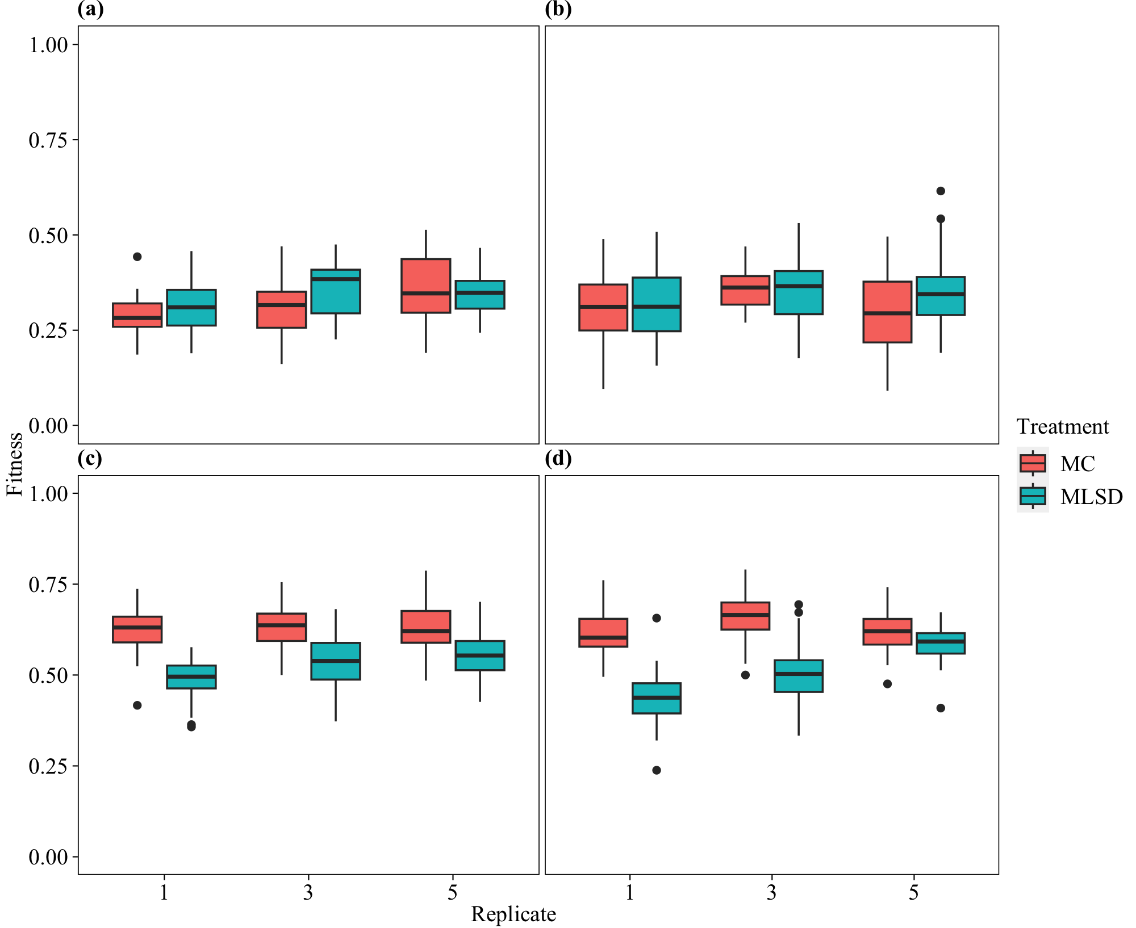

**Figure 2.**

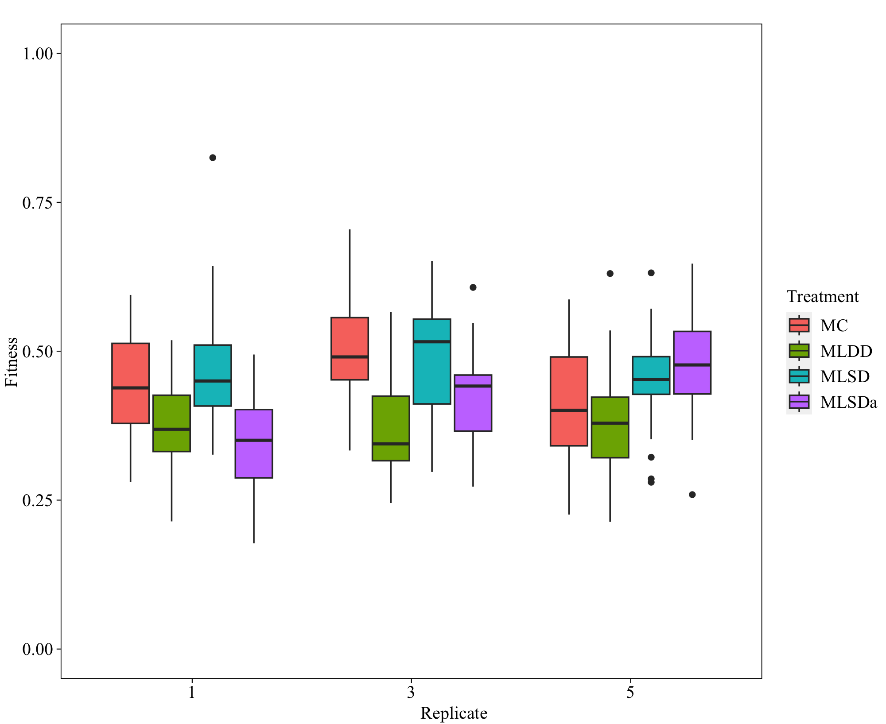

**Figure 3.**

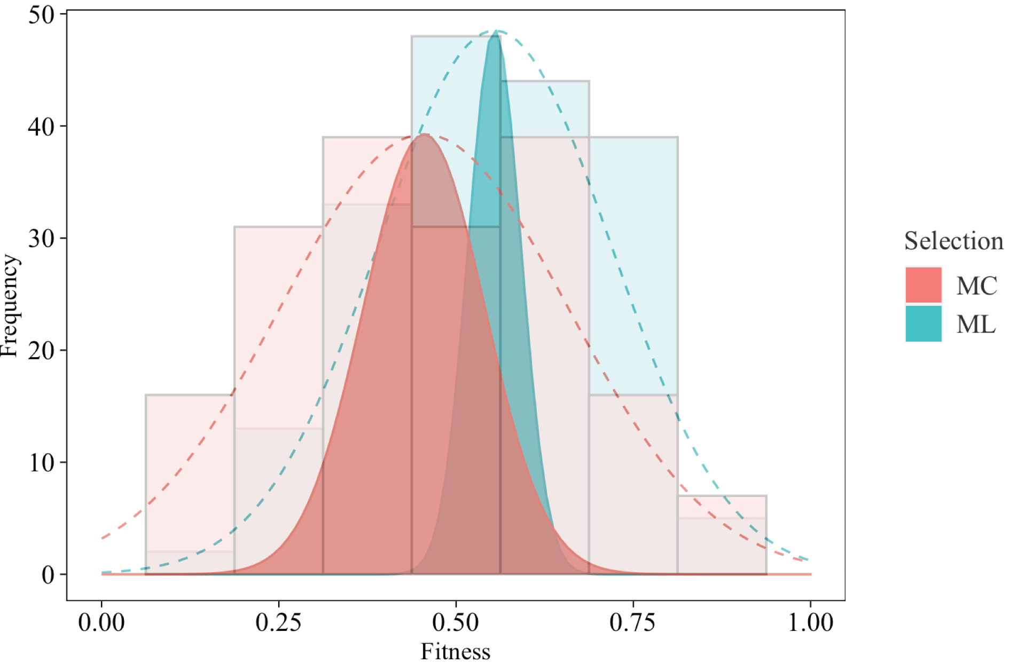

**Figure 4.**

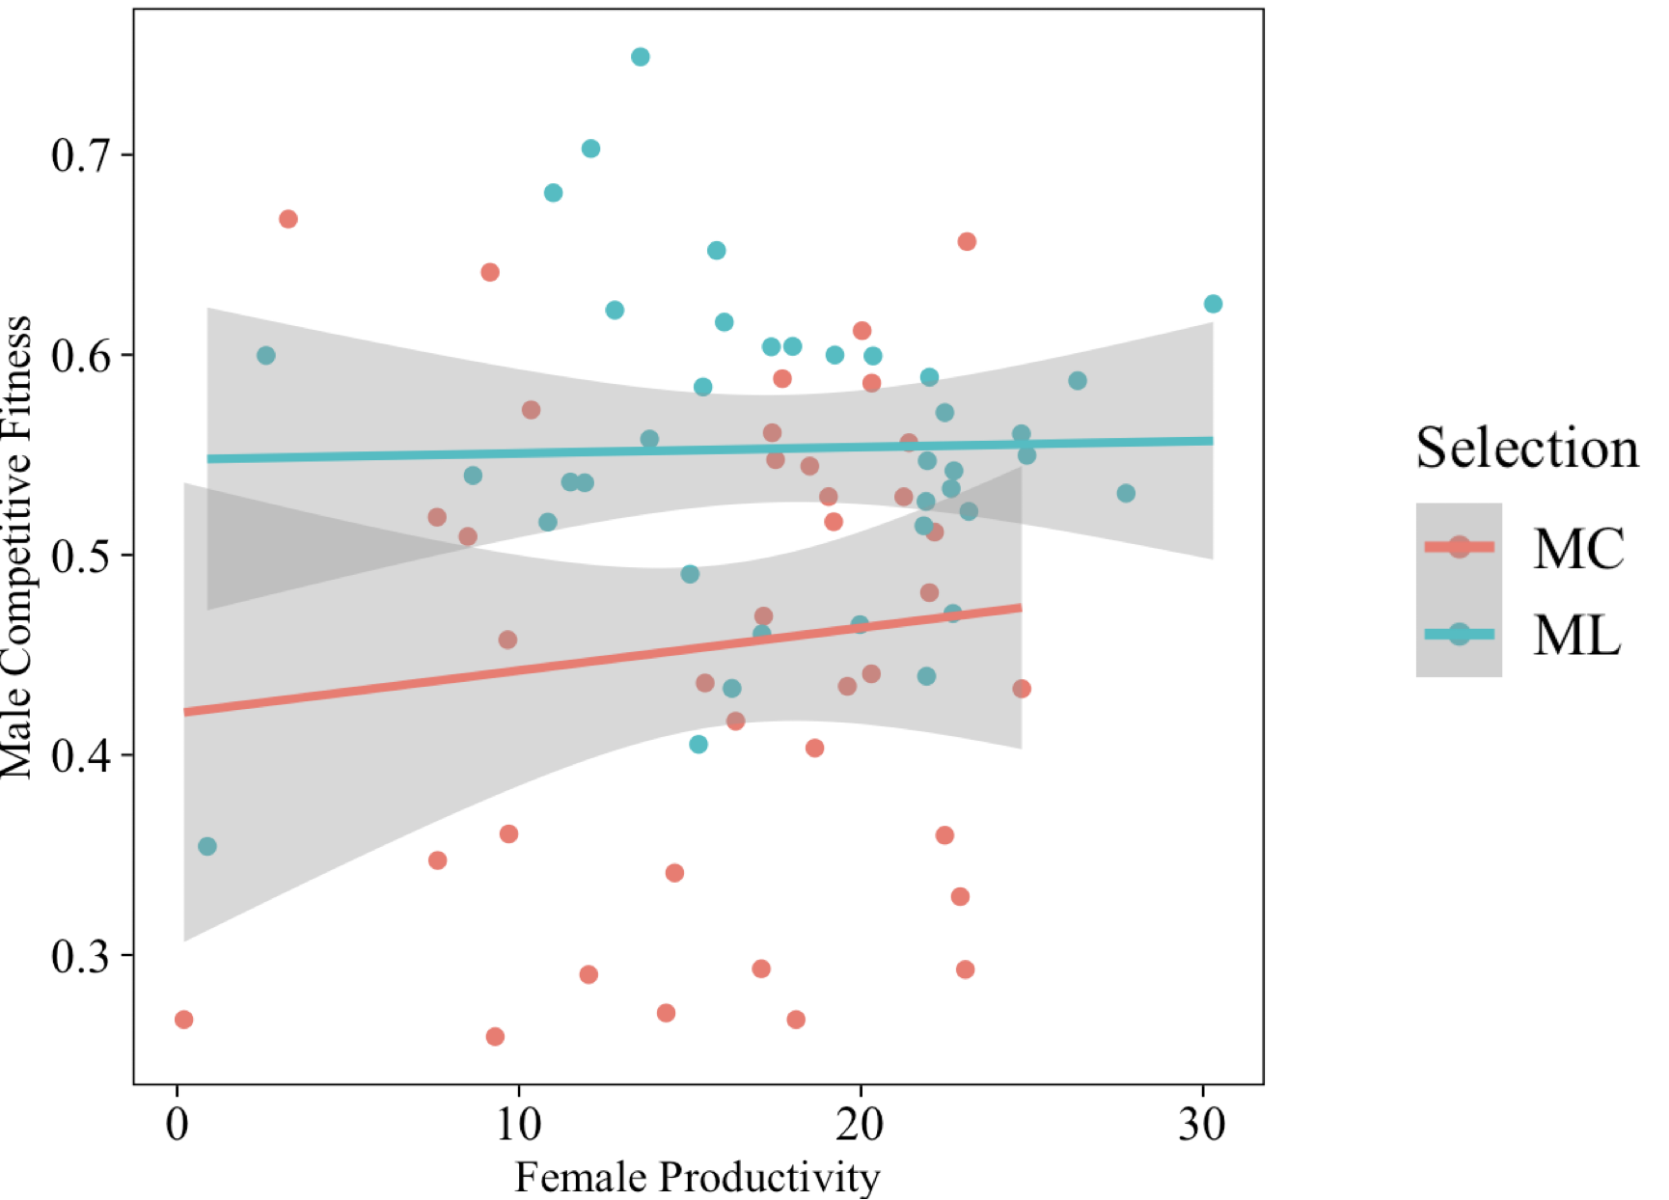

**Figure 5.**

**Figure 6.**

